How To Schedule Your Posts
Facebook Creator Studio for Facebook And Instagram

Creator Studio brings together all the tools you need to effectively post, manage, monetise and measure content across all your Facebook Pages and Instagram accounts. It also helps you take advantage of new features and monetisation opportunities that you may be eligible for.

Anyone who manages a Page can use Creator Studio, although your Page role determines the specific information you see and the actions you can take.

To access it, go to Creator Studio or Google Search “facebook creator studio” and log in.

Post Facebook content from a computer using Creator Studio

There are a few different ways you can upload, compose and post new Facebook content from the Home tab in Creator Studio.

- Click Create Post.
- Click Post something....
- Click Upload video/create post.
Depending on which format you choose, a post composer will appear where you'll be asked to enter additional information. For example, if you select Video, you'll be asked to upload a file, then add a title, a description, tags to help people find your video and a variety of other options.

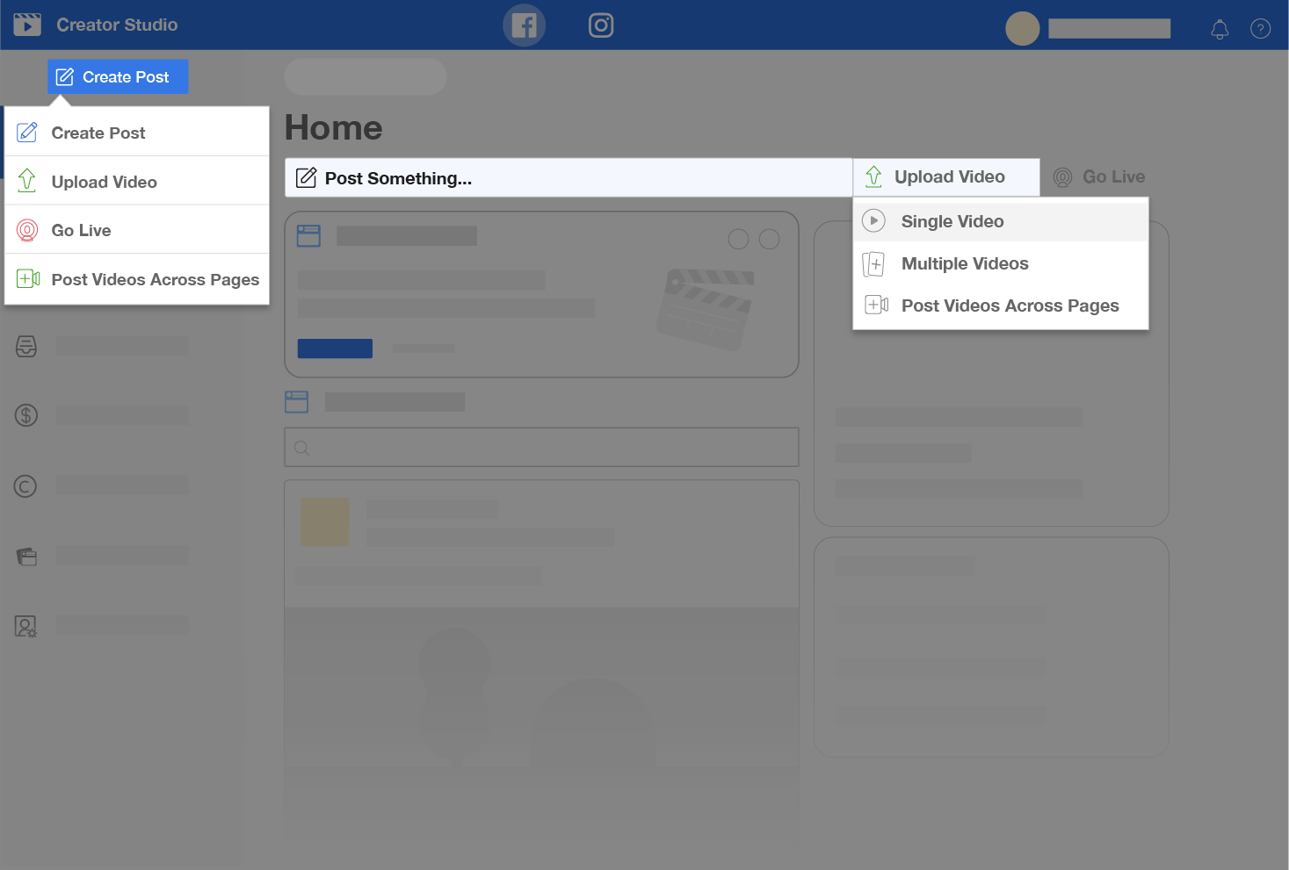

Post Instagram content from a computer using Creator Studio
You can publish, schedule, draft and edit Instagram posts from your computer using Creator Studio.

Before you begin

- Connect to Instagram in Creator Studio.
- Click to go to the Instagram section.

Post to Instagram feed
To upload and post content to Instagram feed from Creator Studio:

- Click Create Post.
- Click Instagram feed.
- If you have more than one Instagram account connected, select the account you want to post to.
- Add a caption (max. of 2,200 characters, 30 mentions and 30 hashtags) and add a location (optional).
- Click Add content to choose the photos or videos you'd like to post. Next, choose between these two options:
- Click From file upload to upload new content. Learn more about image resolution and aspect ratios on Instagram.
- Click From Facebook Page to post content that you've already shared on your Facebook.

To tag accounts in your photo:

- Select on the bottom of your photo.
- Type the account name.
- Select Save.

To crop photos:
- Select on the bottom of your photo.
- Adjust the photo.
- Select Save.

To tag a business partner for a branded post:
- Select Advanced settings.
- Type the name of the partner's account in the Search for a business partner... field.
- Select the business partner.

Schedule posts to Instagram feed
To schedule a post to go live on your Instagram feed at a later date:

- Follow steps 1-6 for "Post to your Instagram feed".
- Click the arrow next to Publish.
- Select Schedule.
- Choose the date and time at which you want your content to post on your Instagram feed.
- Click Schedule.

If you want to simultaneously post this content to the Facebook Page connected to your Instagram account, tick the box next to your Page under Post to Facebook.
You can add additional details to your Facebook post after you publish to Instagram.
Click Publish.

Save, Schedule and Backdate Posts in Creator Studio
To save, schedule or backdate posts in creator studio, first go through the initial steps to compose a post, but stop before clicking Publish. Instead, click the arrow next to Publish and select from the following:

Save
If you are not ready to publish the post yet and want to work on it later, click the arrow next to Publish, then click Save as Draft. You can see all of your drafts in the Drafts section of the Content Library.

Schedule
To determine a future date and time you want to publish your post, click the arrow next to Publish, then click Schedule. You can access all of your scheduled posts in the Scheduled tab in the Content Library.

To reschedule a previously scheduled post:

- Go to the Content Library.
- Click Scheduled.
- Find the post you want to reschedule and hover over it.
- Click then click Reschedule.

Backdate
To determine a date and time when you want the post to stop showing in News Feed, click the arrow next to Publish, then click Backdate. The post will still be visible, but its News Feed distribution will end at the date you select.

Buffer for Twitter

Step 1:
Connect your social media accounts
Once you have signed up for a free account on Buffer, the first thing you need to do to get started is to connect each of your social accounts. Using a free account, Buffer allows you to connect four separate social media accounts including Twitter, Facebook, LinkedIn and Google+.

To do this, all you need to do is click the + symbol written next to the word Accounts on your Buffer dashboard:
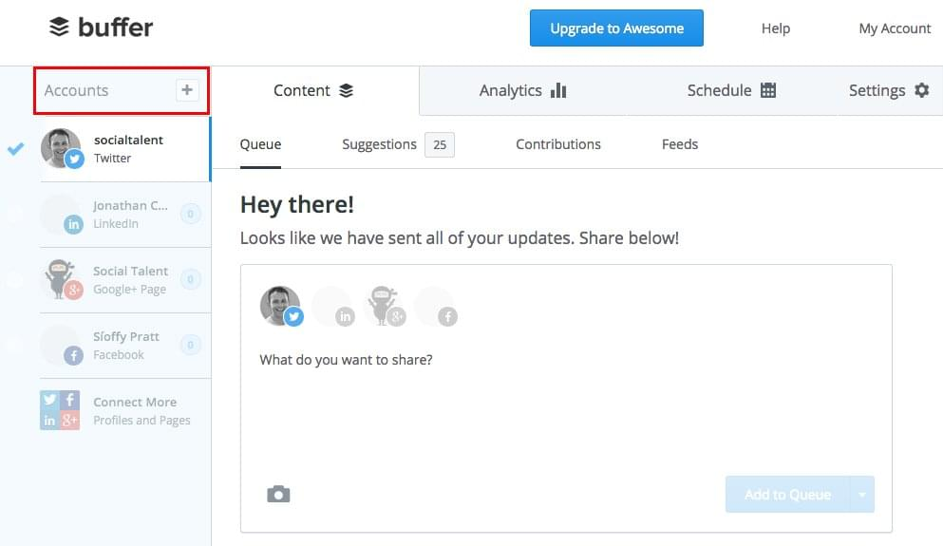

Once in the Accounts tab, you will be prompted to connect each of your accounts. Depending on the type of account you have for each social channel, select the relevant button e.g. if you wish to connect your Twitter profile, click connect under the Twitter section:

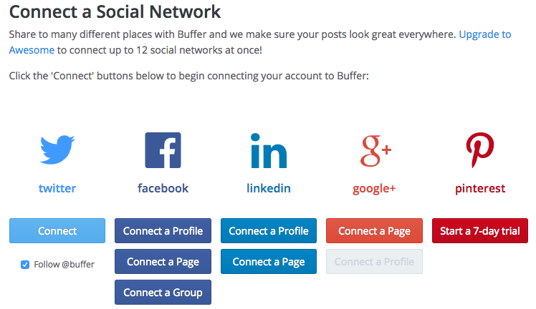

Step 2:
Schedule the times you want your content to post
Once you’ve connected all your relevant accounts the next thing you need to do, for each account, is to choose the days you want your content to post and the times you would like it to post at.

This is where free tools like Tweriod come in handy. They can inform you as to when the best time to post your various social updates is according to your unique audience of followers, and you can use Buffer to ensure your content is posted at those times.

Select the Schedule tab at the top of your Dashboard and ensure that the account you wish to set days and times for is also selected on the left hand side of the Dashboard. Like in this example:
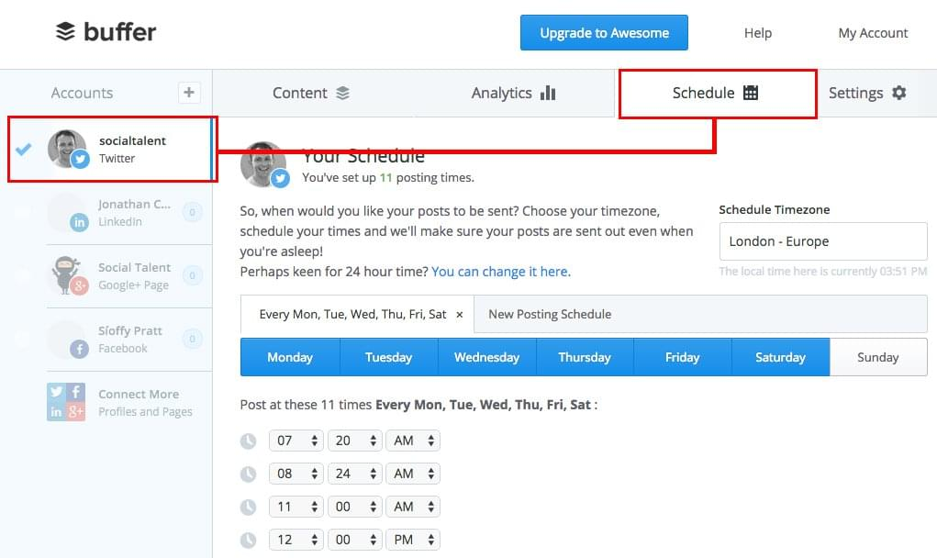

Select your timezone first (ours is London – Europe), then select the days you want to post content on. For example, for this Twitter account, the content is scheduled to post on Monday, Tuesday, Wednesday, Thursday, Friday and Saturday. You can select and deselect days as appropriate to you:
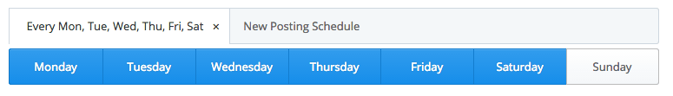

The next thing you need to do is add a posting time. In the example below, they have selected to post on their Twitter account several times during the day, beginning at 7:20am and finishing up at 9pm. To add your own time just click the Add Posting Time button and use the arrows to select the time you want. You can be as specific as you like e.g. 2:37pm:
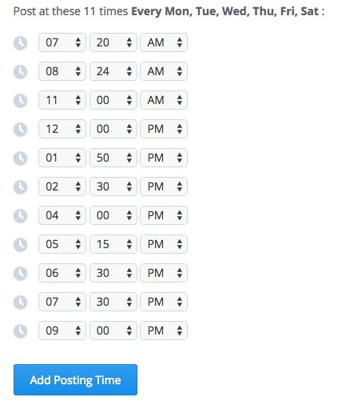

Step 3:
Write the content you want to share
Now that you have selected the days and times you want your content to post, it’s time to start writing the updates you want to post via Buffer.

To do this, select the Content tab at the top of your Dashboard and further select the Queue option:
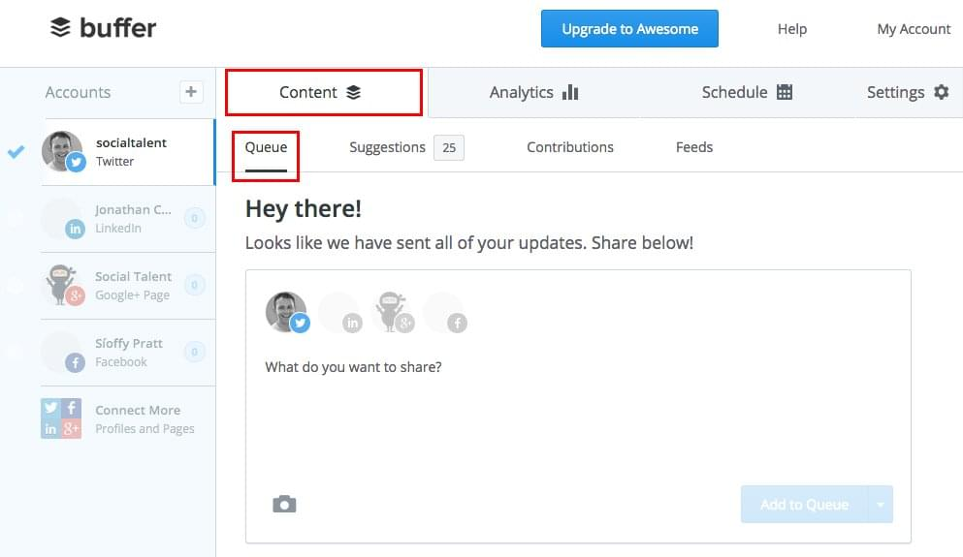

Now all you need to do is start typing and start adding images/videos if any. Check out the example below:
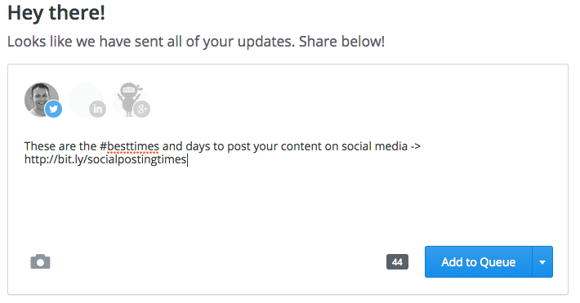

Step 4:
Share your content
When you’ve written your content update, you then need to decide what to do with it. Buffer gives you four options when posting content:

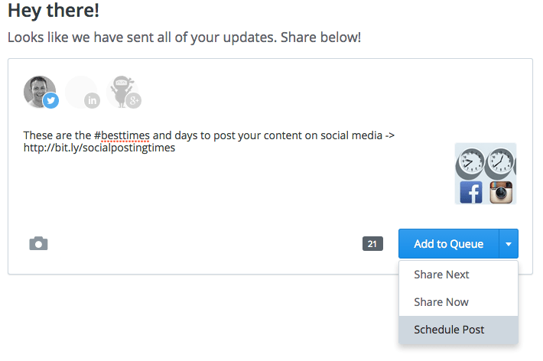
- Add to Queue – click this and your update will be added to your queue of content updates to be posted according to your pre-selected posting times from Step 2 e.g. if this was your first update it will post at 7:20am, if it was your second update you’d post after the first update in the second time slot of 8:24am etc.
- Share Next – click this and your update will be posted at the next available time according to your pre-selected posting times from Step 2
- Share Now – click this and your update will be posted immediately
- Schedule Post – click this and your update will be posted at a specific time on a specific date of your choosing

