How To Schedule Your Posts
Buffer for Twitter

Step 1:
Connect your social media accounts
Once you have signed up for a free account on Buffer, the first thing you need to do to get started is to connect each of your social accounts. Using a free account, Buffer allows you to connect four separate social media accounts including Twitter, Facebook, LinkedIn and Google+.

To do this, all you need to do is click the + symbol written next to the word Accounts on your Buffer dashboard:
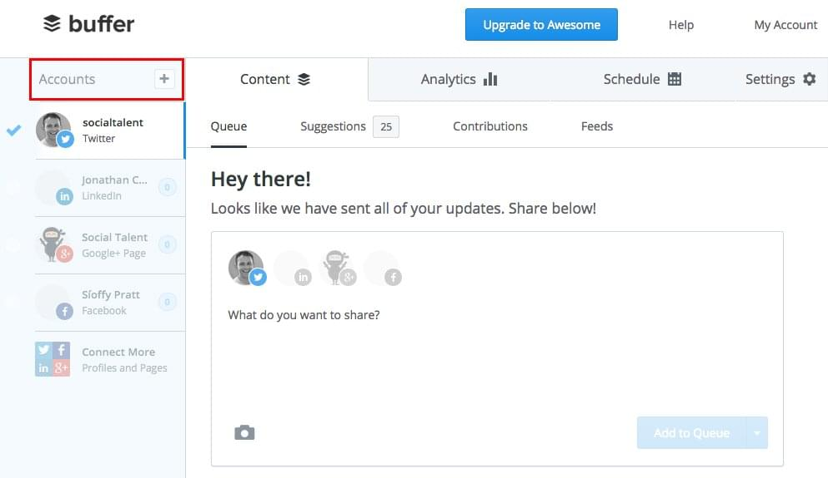

Once in the Accounts tab, you will be prompted to connect each of your accounts. Depending on the type of account you have for each social channel, select the relevant button e.g. if you wish to connect your Twitter profile, click connect under the Twitter section:

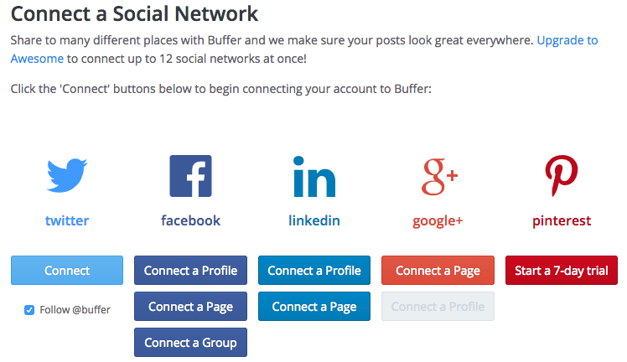

Step 2:
Schedule the times you want your content to post
Once you’ve connected all your relevant accounts the next thing you need to do, for each account, is to choose the days you want your content to post and the times you would like it to post at.

This is where free tools like Tweriod come in handy. They can inform you as to when the best time to post your various social updates is according to your unique audience of followers, and you can use Buffer to ensure your content is posted at those times.

Select the Schedule tab at the top of your Dashboard and ensure that the account you wish to set days and times for is also selected on the left hand side of the Dashboard. Like in this example:
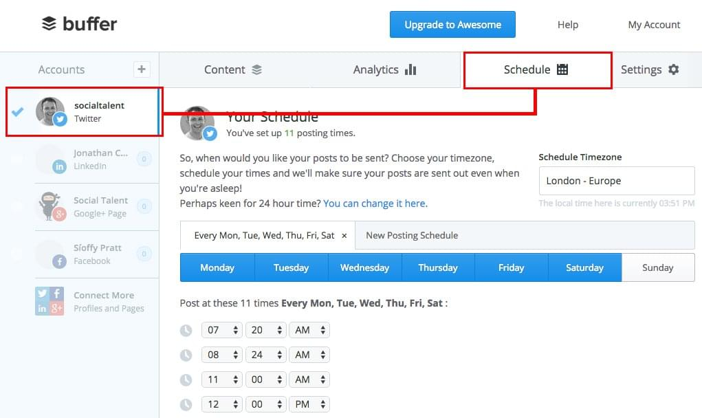

Select your timezone first (ours is London – Europe), then select the days you want to post content on. For example, for this Twitter account, the content is scheduled to post on Monday, Tuesday, Wednesday, Thursday, Friday and Saturday. You can select and deselect days as appropriate to you:
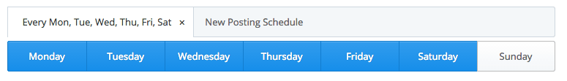

The next thing you need to do is add a posting time. In the example below, they have selected to post on their Twitter account several times during the day, beginning at 7:20am and finishing up at 9pm. To add your own time just click the Add Posting Time button and use the arrows to select the time you want. You can be as specific as you like e.g. 2:37pm:
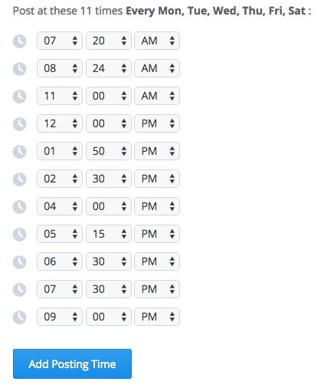

Step 3:
Write the content you want to share
Now that you have selected the days and times you want your content to post, it’s time to start writing the updates you want to post via Buffer.

To do this, select the Content tab at the top of your Dashboard and further select the Queue option:
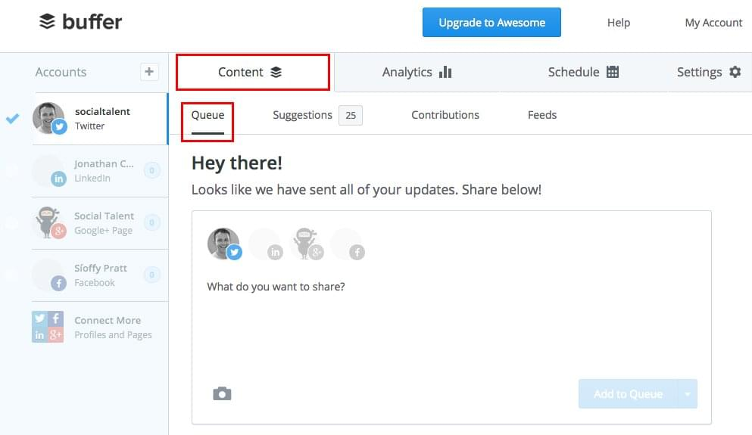

Now all you need to do is start typing and start adding images/videos if any. Check out the example below:
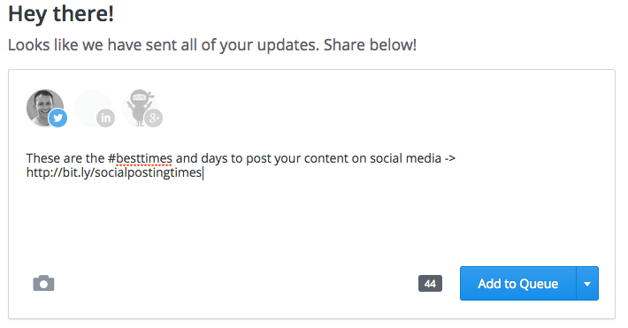

Step 4:
Share your content
When you’ve written your content update, you then need to decide what to do with it. Buffer gives you four options when posting content:

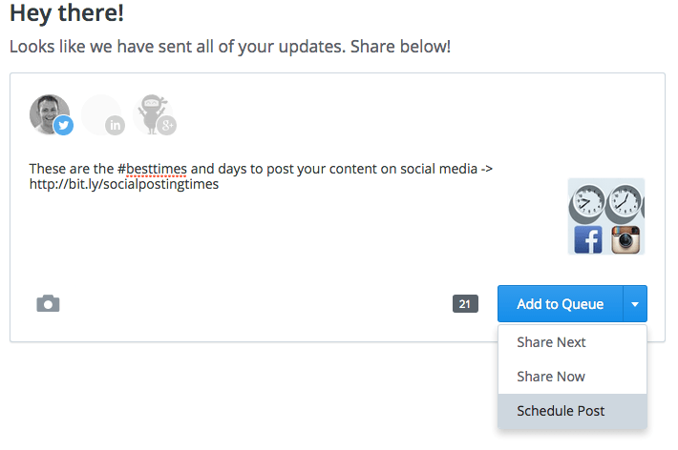
- Add to Queue – click this and your update will be added to your queue of content updates to be posted according to your pre-selected posting times from Step 2 e.g. if this was your first update it will post at 7:20am, if it was your second update you’d post after the first update in the second time slot of 8:24am etc.
- Share Next – click this and your update will be posted at the next available time according to your pre-selected posting times from Step 2
- Share Now – click this and your update will be posted immediately
- Schedule Post – click this and your update will be posted at a specific time on a specific date of your choosing

